LumiTap – Community‑Driven Rhythm Game Platform

Table of Contents
1 Introduction
1.1 Purpose of Writing
1.2 Project Background
1.3 References
2 Overall Description
2.1 Objectives
2.1.1 Development Intention
2.1.2 Application Goals and Scope
2.1.3 Product Prospects
3 Specific Requirements
3.1 Class Diagram
3.2 Properties
3.2.1 Availability
3.2.2 Security
4 Interface Prototype
5 Function Description and Acceptance Verification Standards
5.1 Detailed Function Description
5.2 Input and Output Format
5.3 Interface Acceptance Criteria
5.4 Functional Acceptance Criteria

1 Introduction

1.1 Purpose of Writing
This document defines the requirements for the “Community‑Driven Rhythm Game Platform” project, providing clear and complete specifications for developers, PMs, QA, and stakeholders. It explains system objectives, scope, user scenarios, architecture, and acceptance criteria so that design, development, and testing follow consistent standards and deliver the intended functionality. As part of requirements analysis, this document also demonstrates the team’s application of software‑engineering practices and collaboration.

1.2 Project Background
Software Name: LumiTap
Project Developer: Ciallo～(∠・ω< )⌒★★
The project addresses a market gap for “classic gameplay + open community” in rhythm/MMO spaces and the lack of freedom to choose, edit, and share music resources. LumiTap is a community‑interactive rhythm‑game platform that combines the 4×4 grid tap gameplay of classic arcade titles (e.g., JUBEAT) with a modern user‑generated‑content (UGC) ecosystem. It includes an in‑game chart editor, sharing, and leaderboards to form a sustainable creator/player‑driven ecosystem for rhythm‑game fans, creators, and ACG communities.

1.3 References
To be determined.

2 Overall Description

2.1 Objectives

2.1.1 Development Intention
Leverage database and UI technologies to deliver a smooth UI and the novel 4×4 grid tap gameplay. Foster a compact, high‑quality player community and build a complete score‑creation ecosystem.

2.1.2 Application Goals and Scope
Application Goals:
• Provide a rich, free gameplay experience through a community‑driven library of unlimited songs and charts; support rankings, comments, and sharing to boost immersion and competition.
• Offer convenient tools for creators with a built‑in, intuitive chart editor to create, test, and upload custom charts, continuously growing the content ecosystem.
• Build an active community via uploads, ratings, leaderboards, and social features (e.g., friends), forming a sticky creator–player loop and improving retention.
Application Scope:
Core Functional Modules:
• Gameplay: 4×4 grid rhythm tapping with judgment and JUBEAT‑style scoring.
• Chart Editor: Graphical interface for importing audio, designing timing, and setting difficulty.
• Community Platform: Upload/download charts, comments, ratings, global/friends leaderboards, and content filters.
Target Users:
• Former JUBEAT/arcade rhythm players seeking a free and convenient alternative.
• osu!, Phigros, and other community rhythm‑game enthusiasts who enjoy UGC and interaction.
• Independent musicians and fan creators needing channels to showcase and distribute works.
• General ACG fans and casual players attracted by easy‑to‑learn gameplay.
Platform Scope: The initial version targets PC (Windows/macOS) and can later expand to iOS/Android to reach more users.

2.1.3 Product Prospects
• Sustainable content ecosystem: Under the UGC model, the library grows over time, reducing reliance on official updates and forming a virtuous cycle (“more players → more content”).
• Community‑driven growth: An active community spawns sub‑cultures (e.g., chart‑making tutorials, events). Creator‑incentive programs (virtual rewards, exposure) accelerate ecosystem maturity.
• Technical scalability: The infrastructure supports future iterations such as online battles, AI chart recommendations, and cross‑platform sync; commercialization (donations, creator subscriptions) can sustain operations while keeping the core free.
• Industry influence: Filling the gap of “classic gameplay + open community,” the project can become a benchmark for community‑driven rhythm games and advance user‑participation models.

3 Specific Requirements

3.1 Class Diagram

3.1.1 Domain Model
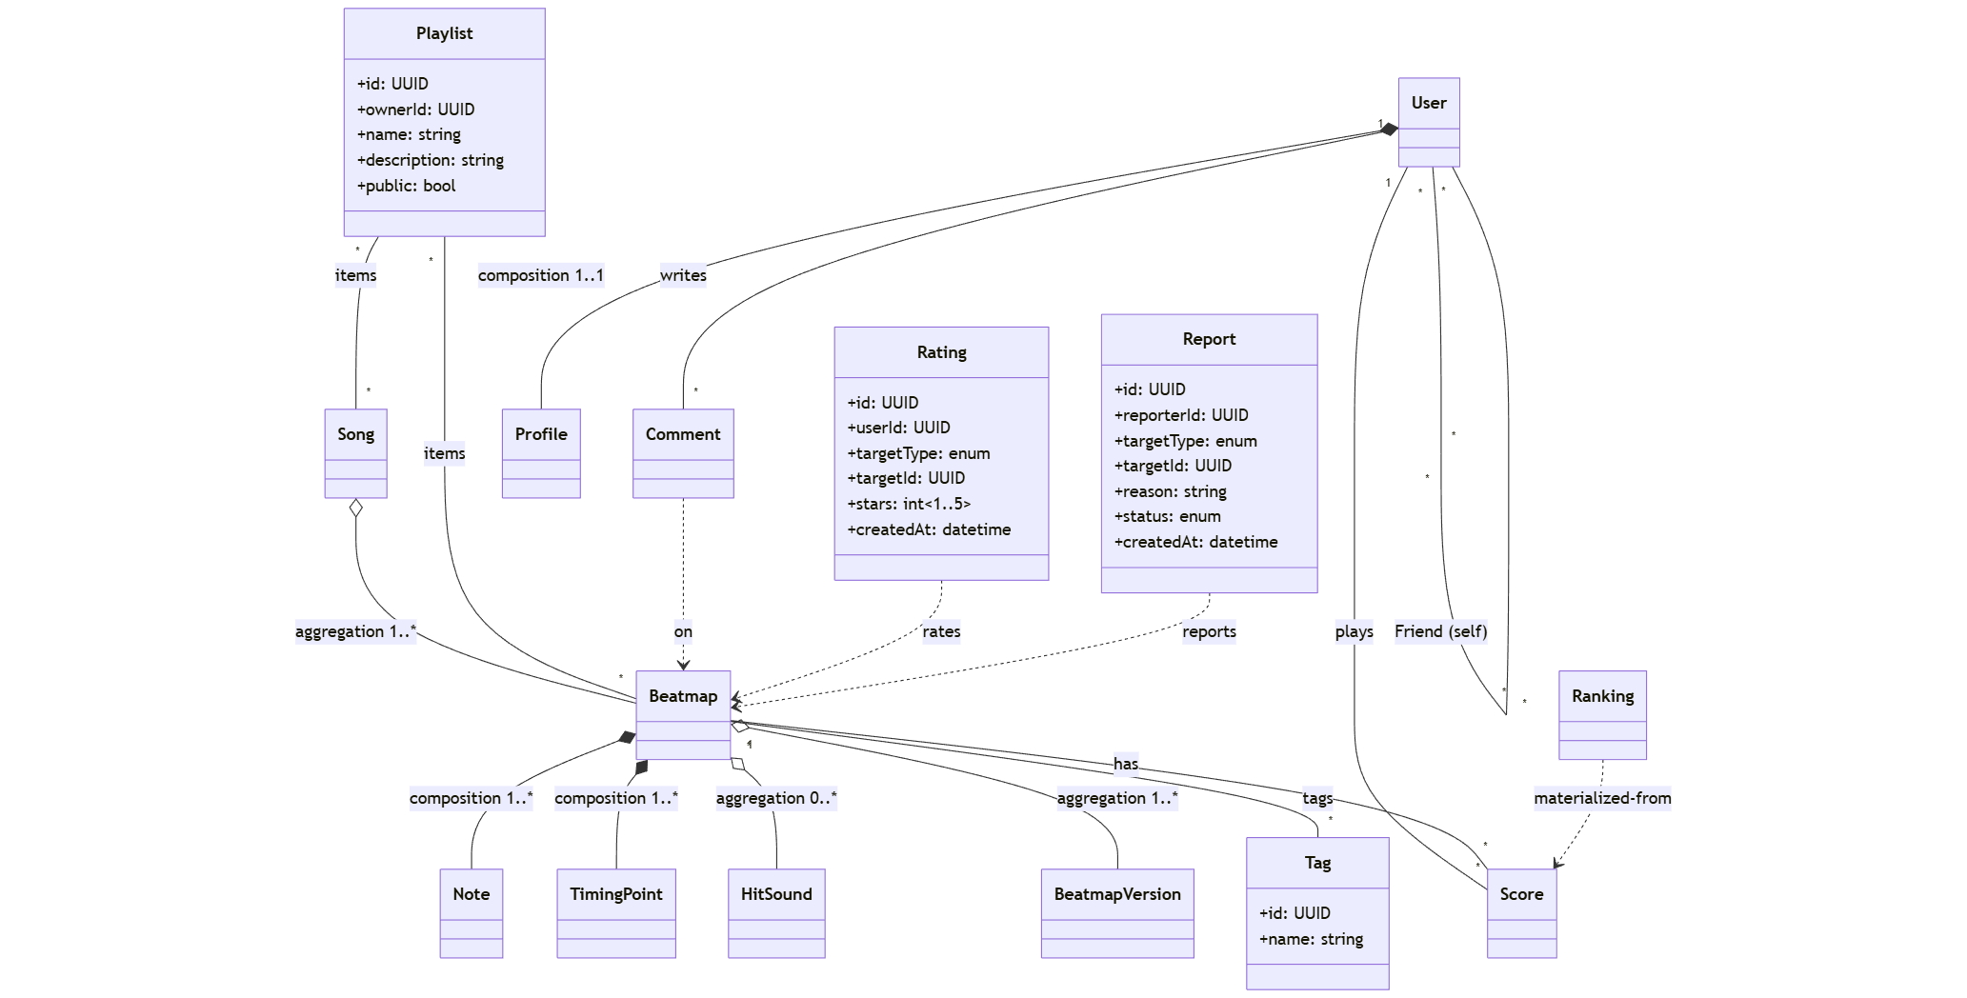

3.1.2 Music Editor
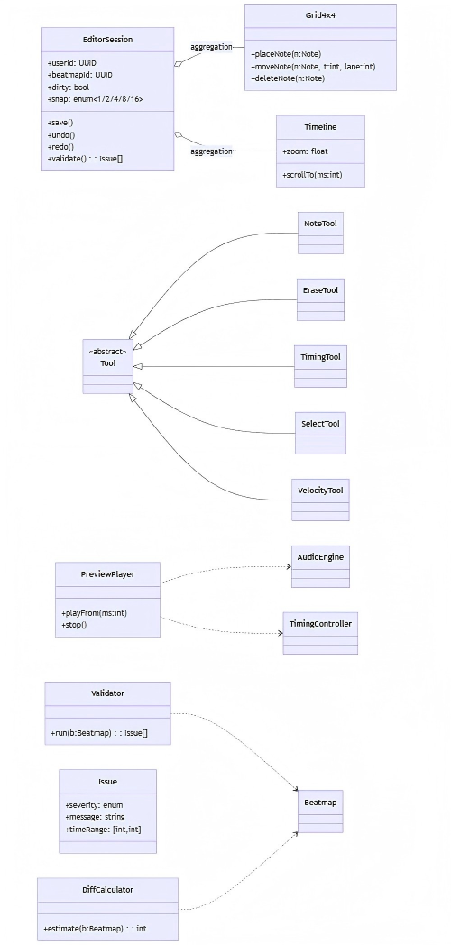

3.1.3 Community and Social
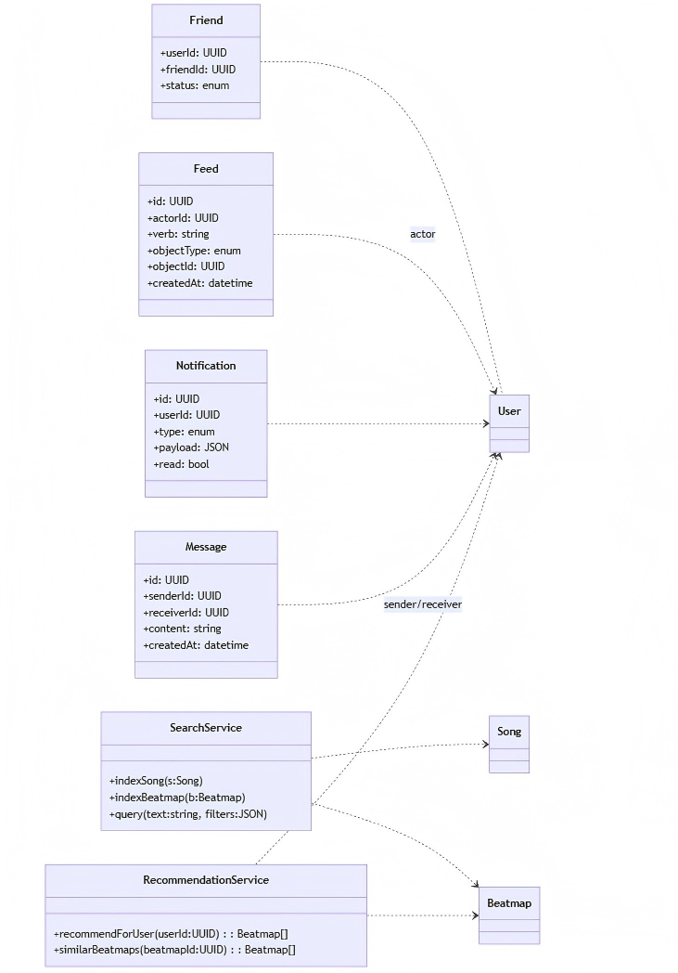

3.2 Properties
The system prioritizes simplicity, accessibility, and community participation while ensuring data reliability and user safety.

3.2.1 Availability
• Target 99% uptime for the game and server components, ensuring access to accounts, scores, and beatmaps at all times.
• Core services—user authentication, beatmap upload, and gameplay synchronization—operate independently so a failure in one does not impact others.
• Use redundant storage for beatmaps and user data to prevent loss.
• Mobile client supports offline play for downloaded beatmaps; results auto‑sync when connectivity is restored.
• Provide scheduled‑maintenance notices at least 24 hours in advance.

3.2.2 Security
• User Authentication: Secure registration/login with hashed passwords (e.g., SHA‑256 or bcrypt).
• Data Transmission: All client–server communication uses HTTPS.
• Access Control: Only authenticated users can upload beatmaps or modify their scores; admins can remove inappropriate content.
• Data Integrity: Verify beatmaps and music files (e.g., checksums) to prevent tampering or malware.
• Privacy Protection: Store personal data (email, password) securely and keep it hidden from other users.
• Backup & Recovery: Periodically back up accounts, scores, and uploaded content to avoid loss from server failures.

4 Interface Prototype
Illustrative screens: Home, Song Selection, Song Search, Gameplay, Score, and Profile. (Placeholders for wireframes/mockups.)

5 Function Description and Acceptance Verification Standards

5.1 Detailed Function Description
LumiTap is a mobile rhythm game for the general public, easy to operate, and supportive of player‑generated content. Gameplay is based on a 4×4 grid; players tap sync to the beat and receive real‑time feedback and scoring. The project includes registration/login, score recording, and leaderboards; players can upload music and charts, browse and share in the community. Tech stack: Vue 3 + Flask, with cloud storage and multi‑platform support.
Account & Authentication – Functional Objectives / Flow:
1) Users register with username, email, and password.
2) The system validates uniqueness and format; on success, data is written to the database.
3) On login, the system verifies email/password; upon success, a Token is generated and returned for storage.
4) Users can log out and clear the Token.
Exceptions: duplicate username/email → “This username/email has already been registered.” Incorrect credentials → “Email or password is incorrect.” Invalid/missing Token → redirect to login.
Content Upload – Functional Objectives / Flow:
1) Select local music (MP3/WAV, ≤50 MB).
2) Validate file format/size.
3) Upload to cloud storage and obtain a file URL.
4) Auto‑generate a chart or upload a custom JSON chart.
5) Bind the chart to the music and save; after success it appears in “My Creations.”
Exceptions: wrong format/size → “Only MP3/WAV and ≤50 MB.” Upload failure → “Network abnormality, please retry.” Auto‑gen failure → “Rhythm recognition failed; please upload a chart manually.”

5.2 Input and Output Format
Module | Input | Output
User Registration | JSON: {username, email, password} | JSON: {status, message, userId}
User Login | JSON: {email, password} | JSON: {status, token, userInfo}
Music Upload | FormData: {file, coverImage, title} | JSON: {status, musicId, url}
Chart Upload | JSON: {musicId, chartData} | JSON: {status, chartId}
Game Score | JSON: {userId, musicId, score, accuracy, combo} | JSON: {status, rank}
Community Comment | JSON: {userId, musicId, comment} | JSON: {status, message}

5.3 Interface Acceptance Criteria
Endpoint | Method | Acceptance Criteria
/api/user/register | POST | 201 on success; 409 if duplicate; 400 for invalid params
/api/user/login | POST | 200 + Token on success; 401 for bad credentials
/api/music/upload | POST | 200 + file URL on success; 415 for format error
/api/game/score | POST | 200 on success; 500 for network/server error
/api/community/comment | POST | 201 on success; 400 if sensitive words detected
/api/community/list | GET | Returns paginated works; empty list if none

5.4 Functional Acceptance Criteria
Module | Item | Criterion
User Registration | Uniqueness | Email/username must be unique
User Login | Token Validity | Token valid for 7 days; re‑login after expiry
Music Upload | File Limits | No files >50 MB or non‑audio formats
Gameplay | Judgment Accuracy | Deviation ≤30 ms = Perfect; ≤70 ms = Good; >70 ms = Miss
Score Upload | Data Completeness | Must include userId, musicId, score, accuracy, combo
Community | Content Moderation | All comments reviewed; sensitive content auto‑filtered
Leaderboards | Update Frequency | Hourly updates; sortable by score/time
Error Handling | User Feedback | All errors return clear messages; no blank/stack traces

